Visit to Tonga dkm April 2023
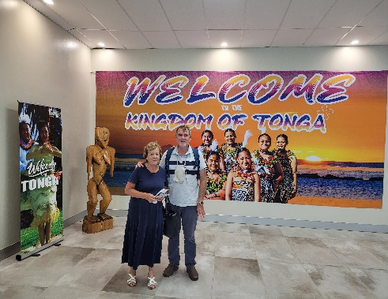
It was in 2010 that the Lord brought a number of Tongan folk to our church in Mt Druitt, families still worshipping with us today. Initially we were checking each other out, mainly because of cultural differences, but we have found a wonderful oneness in the Lord Jesus Christ. I recall attending a birthday party for a Tongan boy and being warmly welcomed, and very well fed! We had a lot to learn about each other’s culture and I was eager to visit this tiny Pacific island to which John Thomas brought the gospel in 1826.
Thomas came to the main island of Tongatapu, but it was in the island groups of Ha’apai and Vava’u to the north that mass conversions began. A local convert called Peta Vi was sent to Ha’apai in 1828, and the king of Ha’apai was converted. A few years later, in the time of Peter Turner, there was a revival, a ‘Tongan Pentecost’ in which all but one of the people in these northern islands was touched by the gospel (paper of Finau Pila ‘Ahio). King Tupou came to the main island of Tongatapu and, after brief resistance, the people of this island were also converted. So the church of Tonga has a glorious history, which I have read about but was eager to see. In March 2023, Elizabeth and I were privileged to visit Tonga, the unique ‘Kingdom of Tonga’, or as written on many signboards, ‘God and Tonga’.
Flying from Fiji to Tonga, we passed over a number of tiny uninhabited island surrounded by turquoise water, a ring of white crashing waves and then the deep blue ocean. We saw this from the ground when we touched down in Tonga and visit Oholei beach resort for a swim. George and Mia from Tupou College met us at the airport and took us to a guest room at the College, where we stayed for five days.
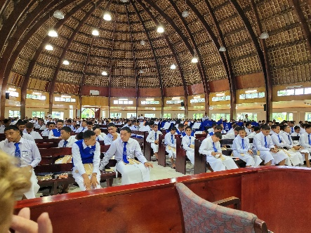
We attended morning worship at Moulton Chapel in the College. We heard the student body of over 800 boys singing Tongan hymns. They had all marched in behind a brass band. The principal was away but we had met him in Sydney prior to our visit- thanks to Hola. We went for a drive in the afternoon but everything was closed on the ‘Sabbath’, according to a law in the constitution. I grew up keeping the Sabbath day holy, so it was pleasing to see a nation abiding by the commands of our God - a command that is a blessing to those who keep it.
Tonga is a blessed nation, especially since the coming of the gospel of Jesus Christ. It has rich soil and plenty of rain (every day we were there), so we feasted on bananas, papaya and coconuts like never before- banana on our cereal, on sandwiches for lunch and sometimes dinner! We enjoyed other food like yams, cassava, and pork of course.
On Monday we drove around the island; yes from one end to the other on the two sealed roads. My GPS had failed but it was hard to get lost on an island just 40km long and half this in width! We saw a resort on the south coast that was completely destroyed by the Tsunami in January 2022. Oholei resort on the east suffered damage also but Virginia’s brother gave us a room for a couple of days and tickets to a Friday night feast and floor show, including fire dancers.
We found the Sia’atoutai Theological College at Nafualu- not far from the home village of Tevita and Lisa. The acting principal welcomed us in the rain, and we gave him some books I had taken. There were about 100 students doing diplomas and bachelor degrees in theology. This is a college of the Free Wesleyan church; it was Methodist missionaries from London and Sydney who first settled in Tonga. Unfortunately liberal theology has infected this church in Australia and there is a danger of this spreading to the College in Tonga. But, thankfully, most Tongan pastors still reject the outworkings of liberal teaching. What, with keeping the Sabbath day holy, exuberant congregational singing, and belief in the authority of the Bible, I see why Christians from Tonga find a home in our church today.

