JOHN HUSS 1369-1415- reformer and martyr (Christianity Today)
John Huss was a hero to Luther and many other Reformers; he preached key Reformation themes (like hatred of indulgences) a century before Luther drew up his 95 Theses. Huss was born in 1369 to peasant parents in "Goosetown," that is, Husinec, in the south of today's Czech Republic. To escape poverty, Huss trained for the priesthood. He earned a bachelor's, master's, and then finally a doctorate from Prague University. Along the way he was ordained (in 1401) and became the preacher at Prague's Bethlehem Chapel (which held 3,000).
The writings of John Wycliffe stirred his interest in the Bible, and these same writings were causing a stir in Bohemia (the northeastern portion of today's Czech Republic, but a general term for the area where the Czech language and culture prevailed). The University of Prague was already split between Czechs and Germans, and Wycliffe's teachings only divided them more. But the Czechs, with Huss, warmed up to Wycliffe's reforming ideas; though they had no intention of altering traditional doctrines, they wanted to place more emphasis on the Bible, expand the authority of church councils (and lessen that of the pope), and promote the moral reform of clergy. Thus Huss began increasingly to trust the Scriptures, "desiring to hold, believe, and assert whatever is contained in them as long as I have breath in me."
Two popes vied to rule all of Christendom. A church council was called at Pisa in 1409 to settle the matter. It deposed both popes and elected Alexander V as pontiff. Alexander was soon "persuaded"-that is, bribed-to side with Bohemian church authorities against Huss, who continued to criticize them. Huss was forbidden to preach and was excommunicated, but only on paper: with local Bohemians backing him, Huss continued to preach and minister at Bethlehem Chapel.
When Alexander V's successor, the antipope John XXIII (not to be confused with the modern pope by the same name), authorized the selling of indulgences to raise funds for his crusade against one of his rivals, Huss was scandalized. The pope was acting in mere self-interest, and Huss could no longer justify the pope's moral authority. He leaned even more heavily on the Bible, the final authority for the church. Huss further argued that the Czech people were being exploited by the pope's indulgences, which was a not-so-veiled attack on the Bohemian king, who earned a cut of the indulgence proceeds.
Huss was excommunicated and withdrew to the countryside in 1412. He spent the next two years composing a number of treatises. The most important was The Church, which he sent to Prague to be read publicly. In it he argued that Christ alone is head of the church, that a pope "through ignorance and love of money" can make many mistakes, and that to rebel against an erring pope is to obey Christ.
In November 1414, the Council of Constance assembled, and Huss was urged by Holy Roman Emperor Sigismund to come and give an account of his doctrine. Because he was promised safe conduct, and because of the importance of the council, Huss went. When he arrived, however, he was immediately arrested, and kept in prison for months. Instead of a hearing, Huss was eventually hauled before authorities in chains and asked merely to recant his views. He refused one last chance to recant at the stake, where he prayed, "Lord Jesus, it is for thee that I patiently endure this cruel death. I pray thee to have mercy on my enemies." He was heard reciting the Psalms as the flames engulfed him.
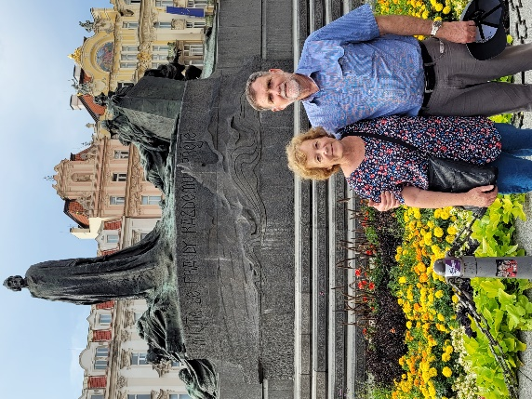
Bohemians were furious with the execution and rejected the council; over the next few years ‘Hussites’ fended off three military assaults. Bohemia eventually reconciled with the rest of western Christendom, except for a group, the Unitas Fratrum ("Union of Brethren"), which became the foundation for the Moravian Brethren (Moravia is a region in the Czech Republic), who would play an influential role in the conversion of the Wesley brothers, among others.

